|  |
| --- |
| PROPERTY MANAGEMENT APPLICATION USING SALESFORCE |
| PROJECT BASED EXPERIMENTAL LEARNING PROGRAM |
| KAVIYA. R |

# 1 .INTRODUCTION

**OVERVIEW**

Salesforce is the World’s number one customer relationship management CRM platform. It helps in marketing sales, service, commerce and IT teams works as one from anywhere in the world.

This can help field sales teams ensure that order fulfilled quickly and accurately and that inventor levels are maintained at optimal levels.

Salesforce is a cloud-based software company that provides its customers with a platform to develop their own applications without following the tough steps that they used to follow in the legacy system.

**PURPOSE**

It aims to produce are time knowledge of the saleforce and how can we build a app using salesforce in this project we build a candidate result card application for educational, which would be useful for the staff to reduce time and track the performance of the student with case.

It is helpful to have large number of data maintained under own platform.

# 2. PROBLEM DEFINITION &DESIGN THINKING

**2.1 EMPATHY MAP**

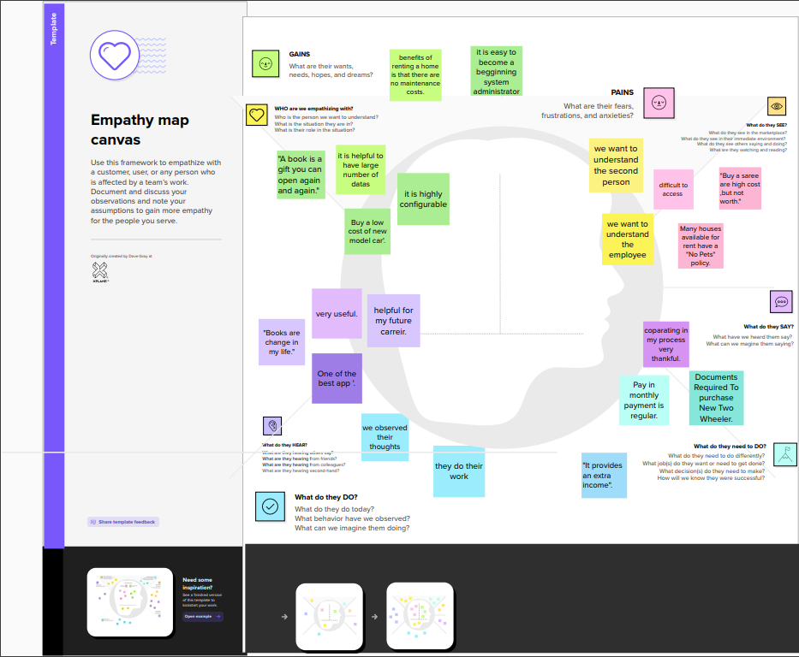

2.2 IDEATION & BRAINSTORMING MAP

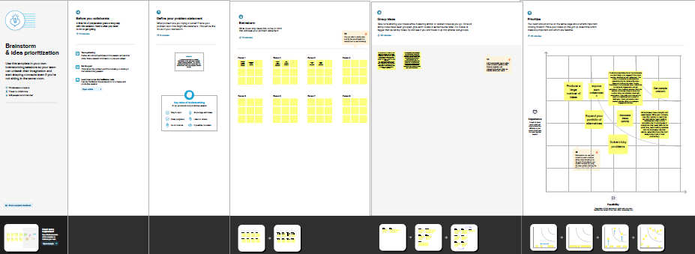

|  |  |
| --- | --- |
| object name | fields in the object |
| buy | |  |  | | --- | --- | | field label | data type | | Buy | Autonumber | |  |  | |
| rent | |  |  | | --- | --- | | Field label | data type | | rent | Autonumber | |  |  | |
| loan | |  |  | | --- | --- | | Field label | data type | | loan | Autonumber | |  |  | |

result

3.1 data model

Property Management Application Using Salesforce

**Project Description:**

Develop an App for the Property Management where Buyer can order his Requirements and get the Appropriate Details of the Property. According to his interest just provide him with some discounts upto what extent he can get the discount. Also Track Whether he is Interested in taking the loan available for so just calculate how much loan Amount user can get it. Provide the Security for two different profiles like for marketing and sales team.

Then Finally Create the reports and dashboard so there will be clear view just get the reports on the count of loan passed getting the property purchased close the deal.

**Milestone 1:**

## Salesforce

**Introduction:**

Salesforce is game-changing technology, with a host of productivity-boosting features, that will help you sell smarter and faster.

**What Is Salesforce?**  
 Salesforce is your customer success platform, designed to help you sell, service, market, analyze, and connect with your customers.

Salesforce has everything you need to run your business from anywhere. Using standard products and features, you can manage relationships with prospects and customers, collaborate and engage with employees and partners, and store your data securely in the cloud.

<https://youtu.be/r9EX3lGde5k>

**Activity1:**

Creating Developer Account

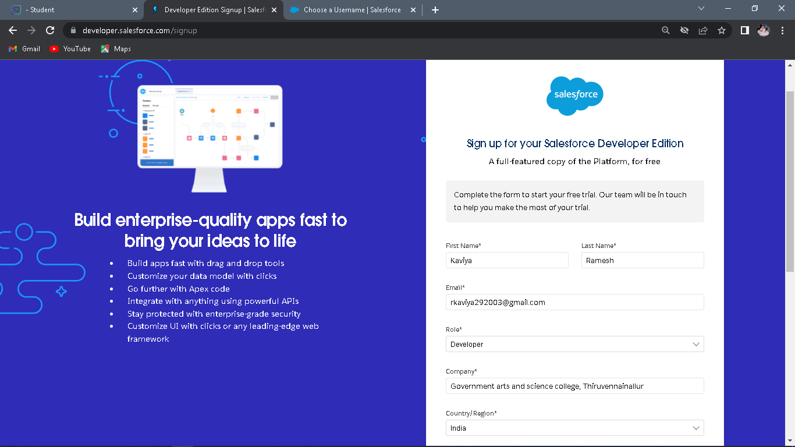

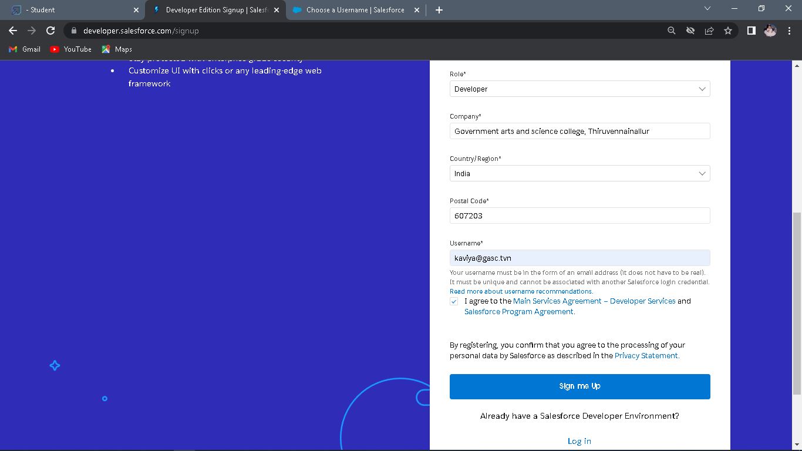

Creating a developer org in salesforce.

1. Go to developers.salesforce.com/

2. Click on sign up.

3. On the sign up form, enter the following details :

a. First name & Last name

b. Email

c. Role : Developer

d. Company : College Name

e. County : India

f. Postal Code : pin code

g. Username : should be a combination of your name and company

This need not be an actual email id, you can give anything in the format :

username@organization.com

Click on sign up after filling these.

**Activity 2-**

**Account Activation 1.**

1. Go to the inbox of the email that you used while signing up. Click on the verify account

to activate your account. The email may take 5-10mins, as

2. Login To Your Salesforce Account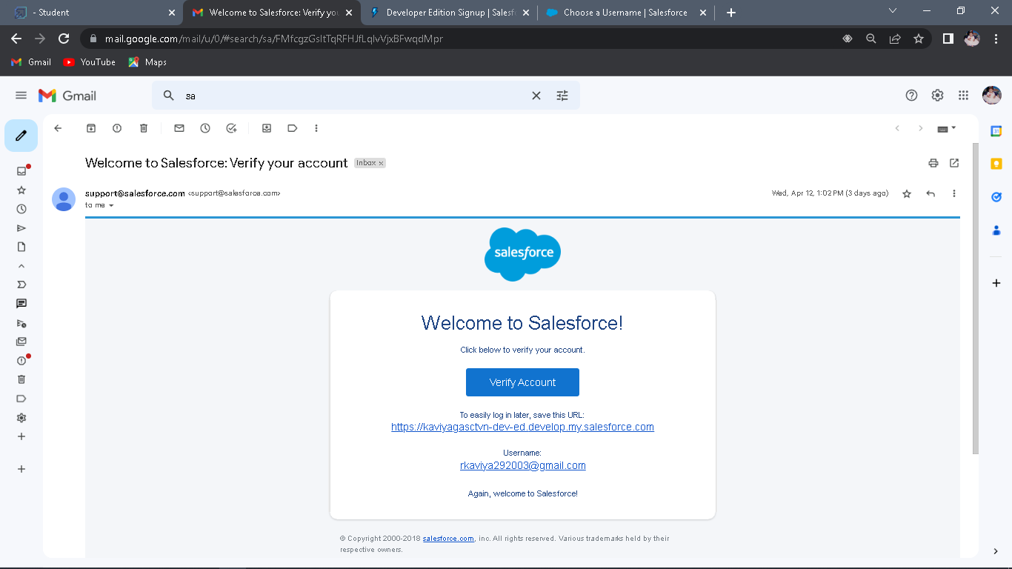

**Milestone 2:**

Object

Salesforce objects are database tables that permit you to store data that is specific to an organization.

**Activity1:**

**Object**

To Navigate to Setup page:

1. Click on gear icon → click setup.

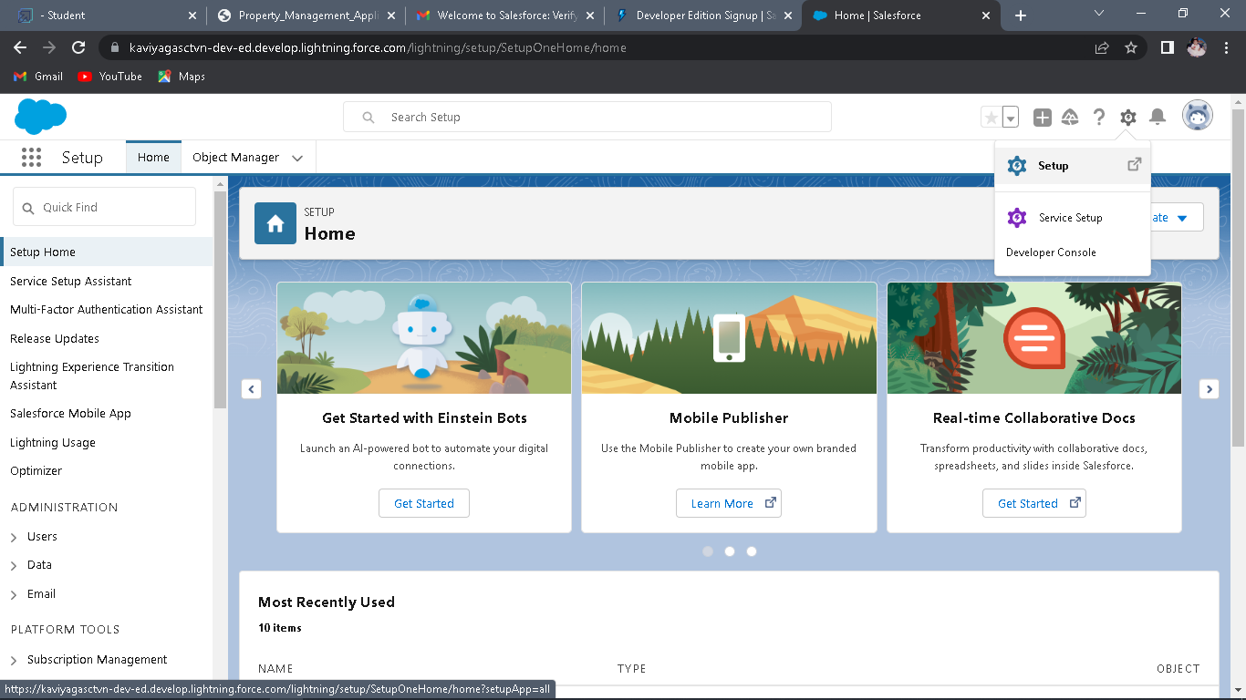 **To create an object:**

2. From the setup page → Click on Object Manager → Click on Create → Click on Custom Object.

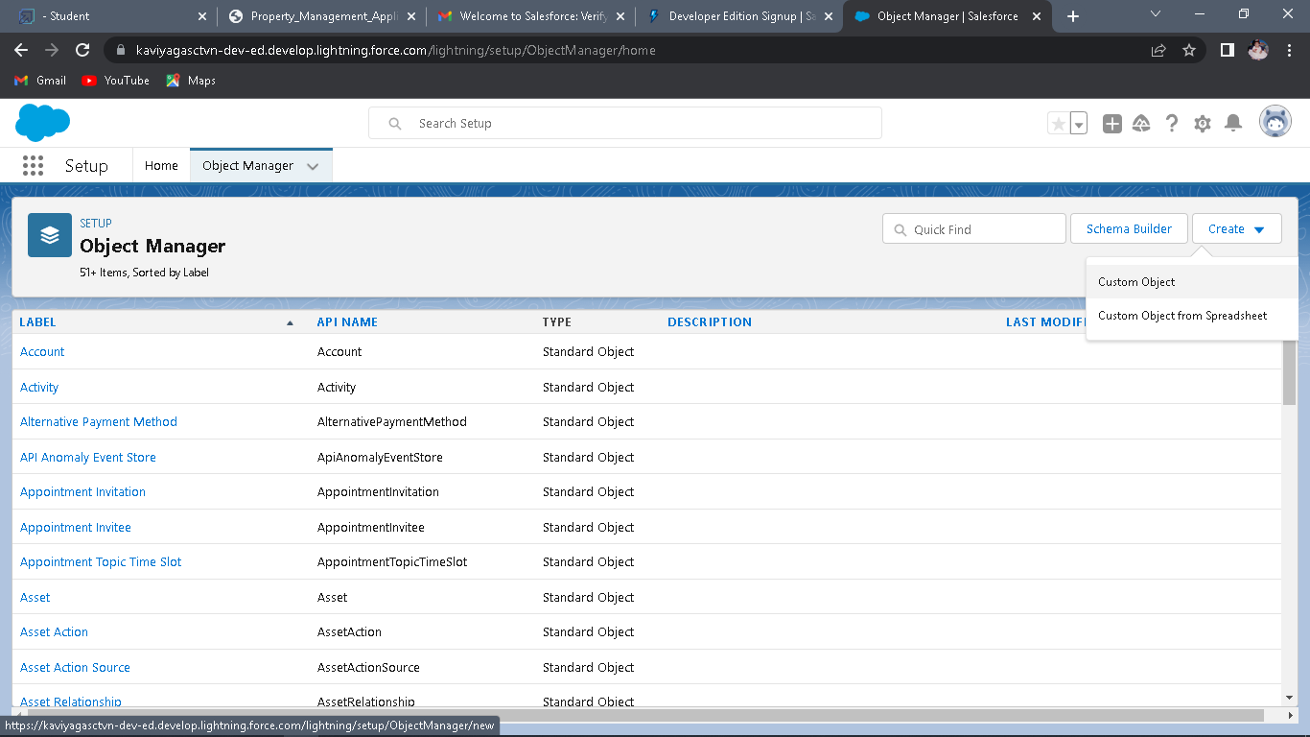

On Custom object defining page:

1. Enter the label name, plural label name, click on Allow reports, Allow search → Save 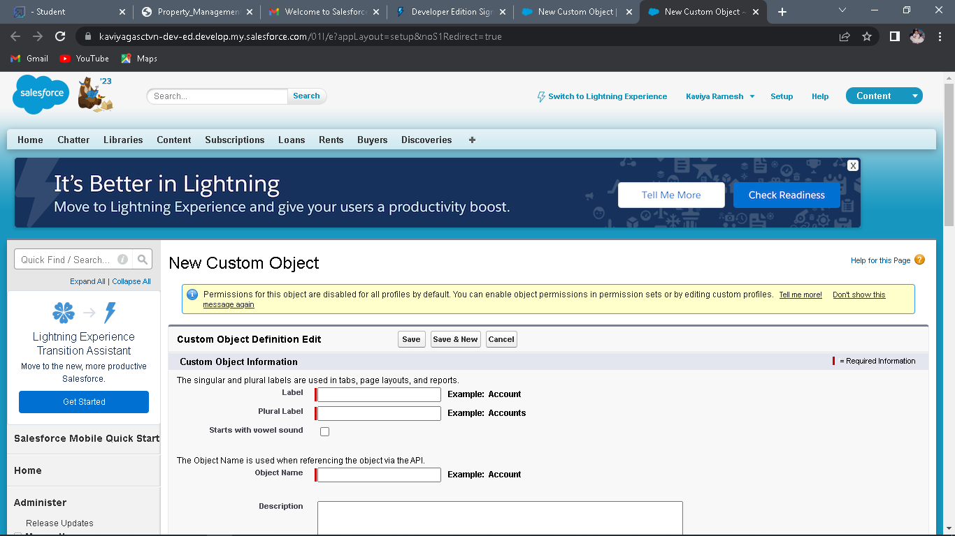

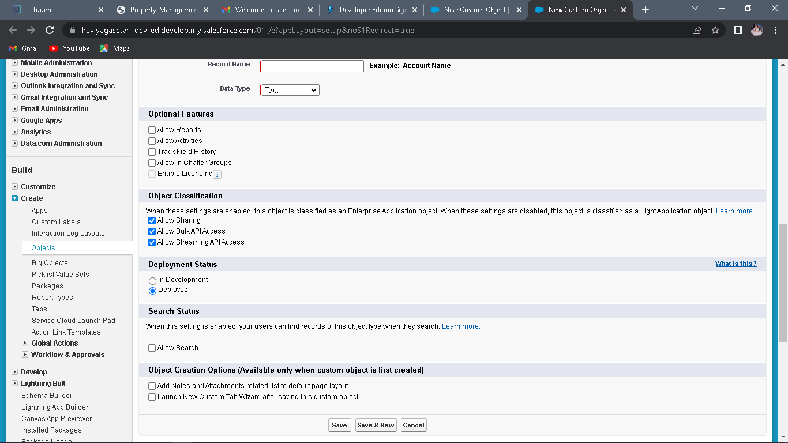

**Activity2:**

**Create Object Buy**

1. To create an object:

2. From the setup page → Click on Object Manager → Click on Create → Click on Custom Object

3. Enter the label name→Buy

4. plural label name→ Buyers

5. click on Allow reports,

6. Allow search → Save

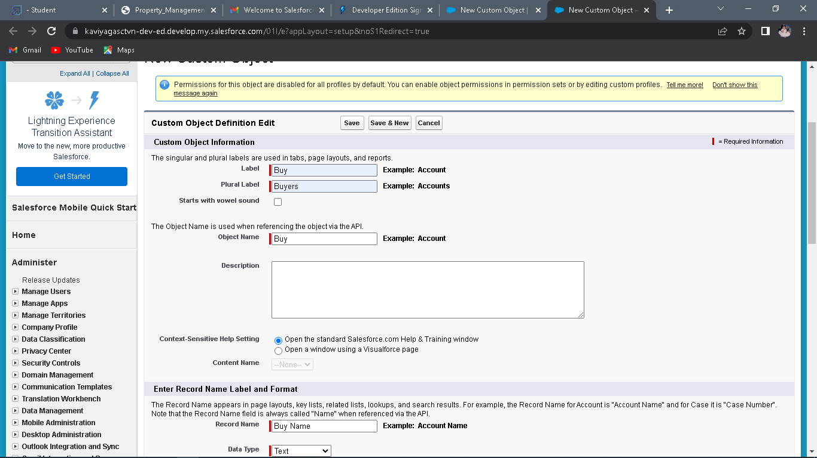

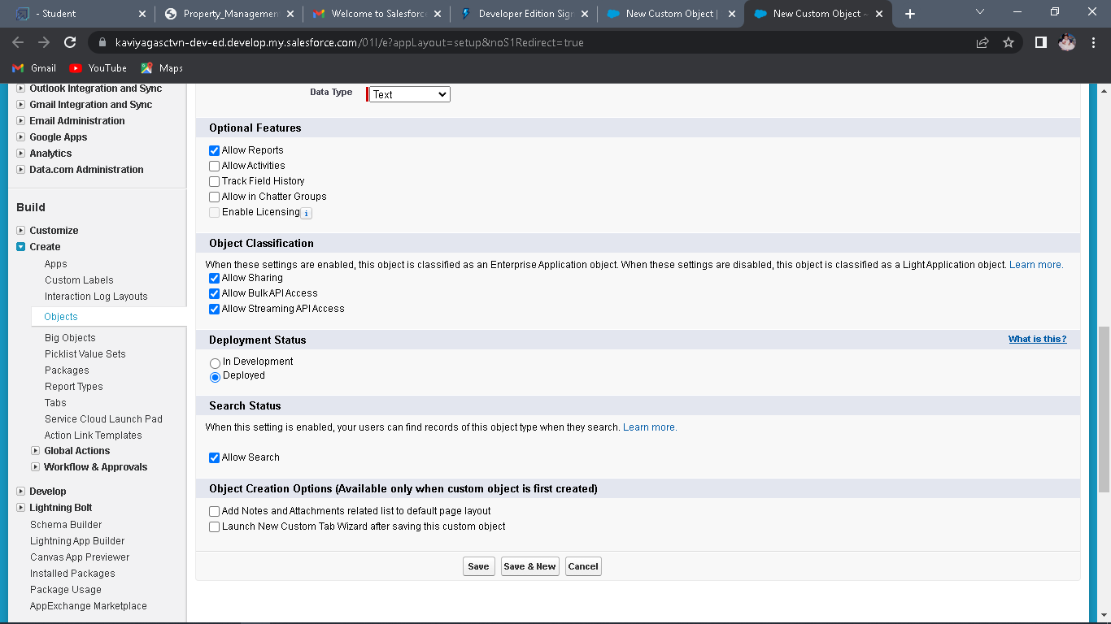

**Activity3**:

**Create Object Rent**

1. To create an object:

2. From the setup page → Click on Object Manager → Click on Create → Click on Custom Object.

3. Enter the label name→Rent

4. plural label name→ Rents

5. click on Allow reports,

6. Allow search → Save

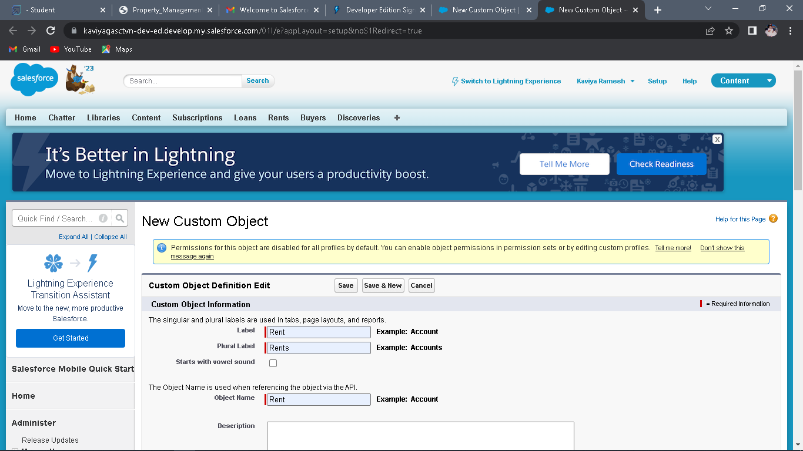

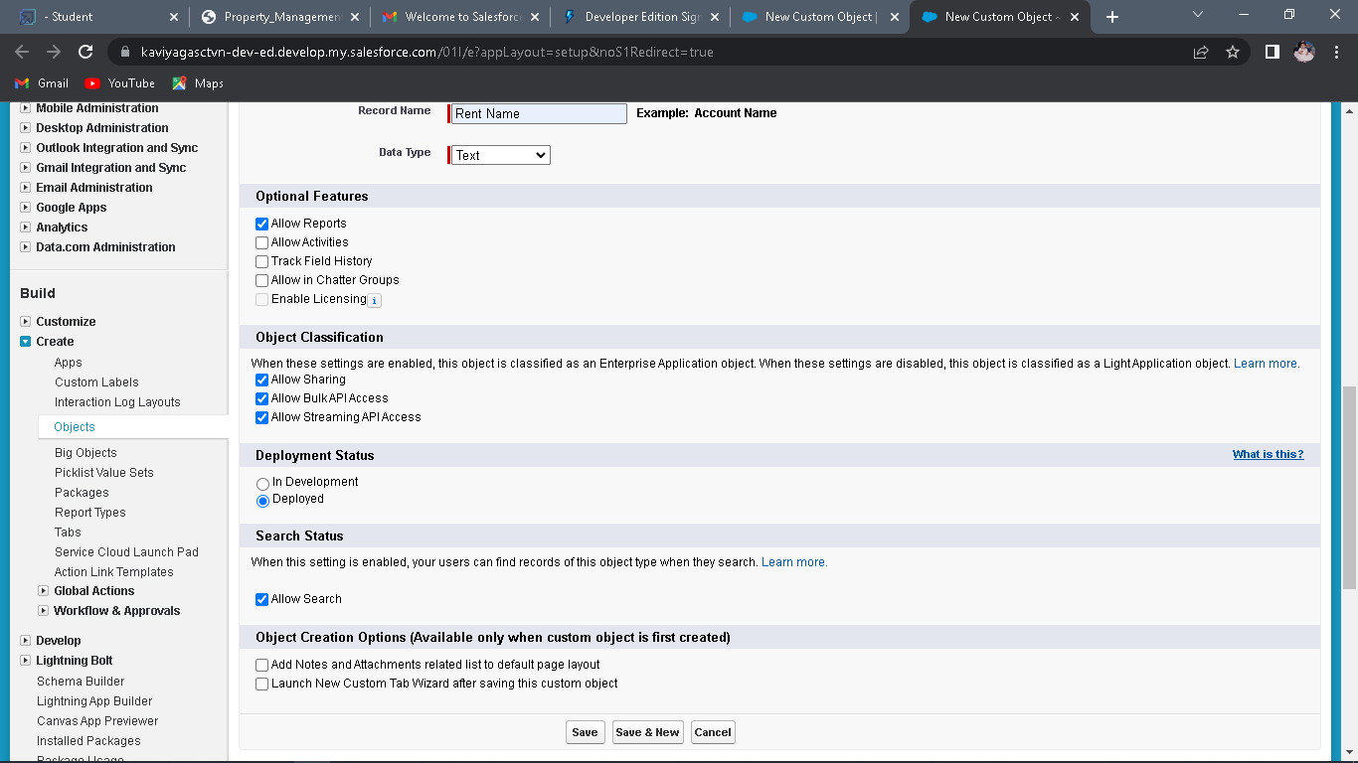

**Activity4:**

**Create Object Loan**

1. To create an object:

2. From the setup page → Click on Object Manager → Click on Create → Click on Custom Object.

3. Enter the label name→Rent

4. plural label name→ Rents

5. click on Allow reports,

6. Allow search → Save

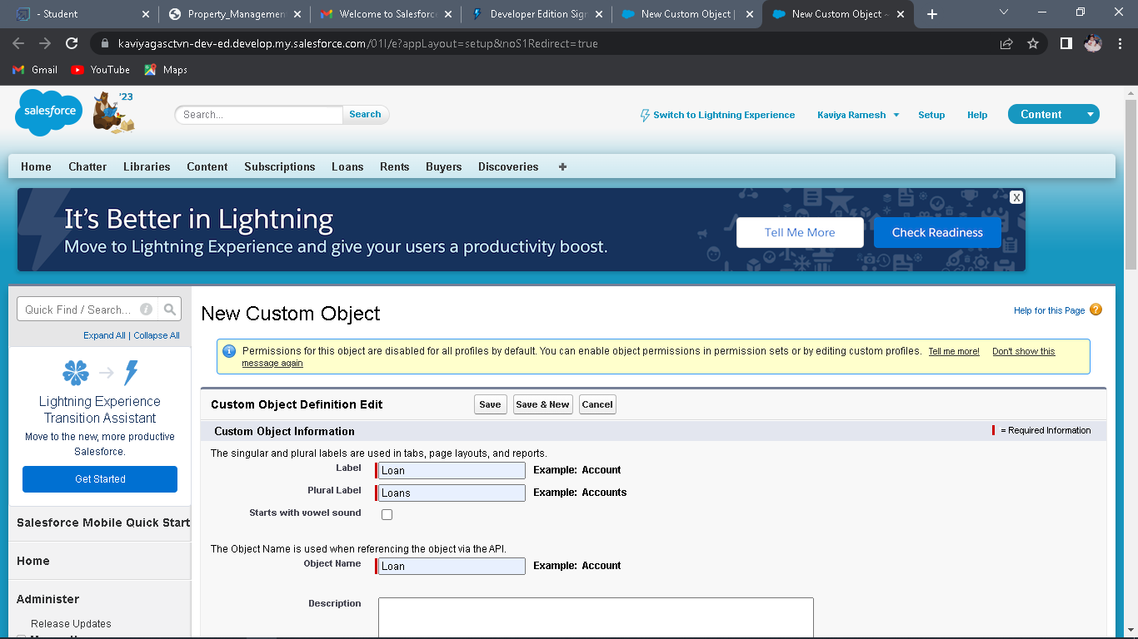

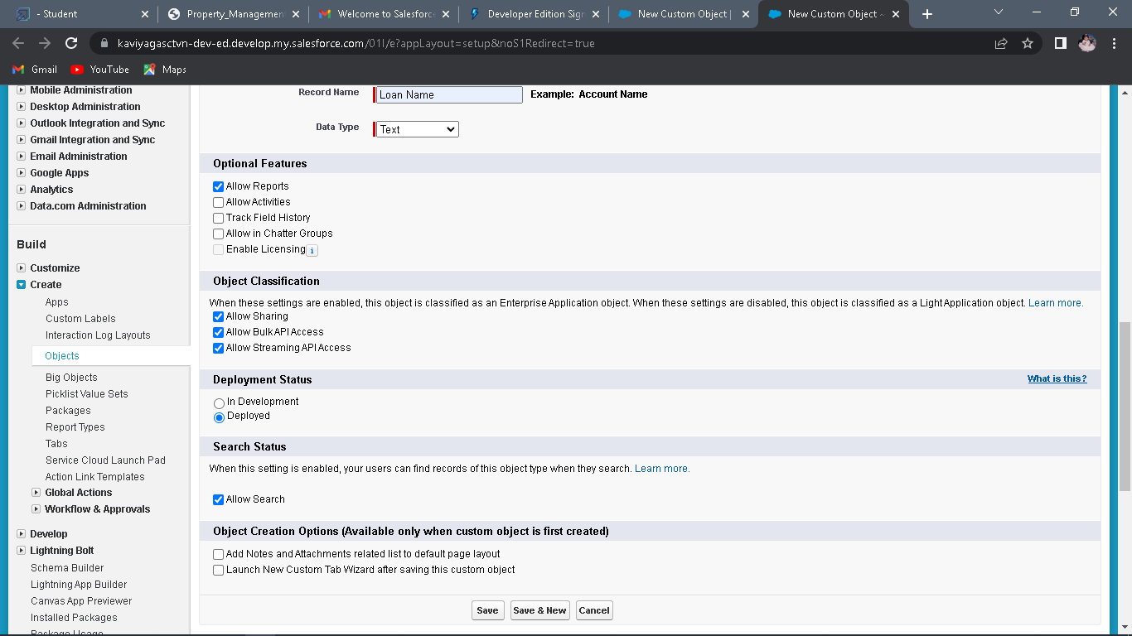

**Milestone 3:**

## Tab

A tab is like a user interface that is used to build records for objects and to view the records in the objects.

**Types of Tab**

● Custom object tab

● Web tab

● Visualforce tab

**Activity 1**:

**Create the Lightning Tab**

**To create a Tab:(Lead)**

1. Go to setup page → type Tabs in Quick Find bar → click on tabs → New (under custom object tab)

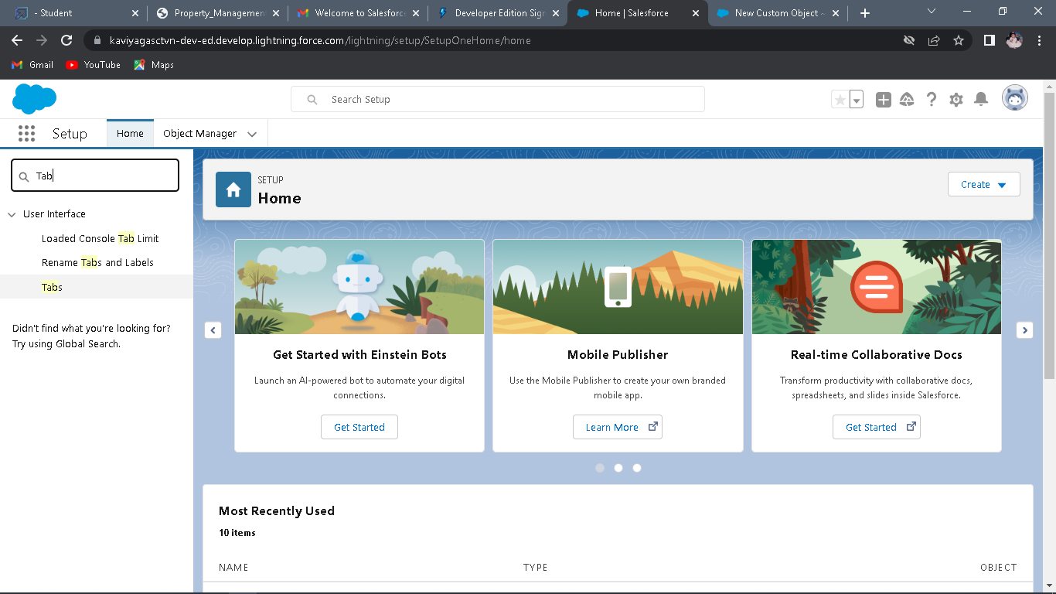

1. Select Object(Lead) → Select the tab style → Next (Add to profiles page) keep it as default → Next (Add to Custom App) keep it as default → Save.

**Activity 2:**

**To create a Tab:(Buy)**

1. Go to setup page → type Tabs in Quick Find bar → click on tabs → New (under custom object tab)

2. Select Object(Buy) → Select the tab style → Next (Add to profiles page) keep it as default → Next (Add to Custom App) keep it as default → Save.

**Activity 3:**

**To create a Tab:(Rent)**

1. Go to setup page → type Tabs in Quick Find bar → click on tabs → New (under custom object tab)

2. Select Object(Rent) → Select the tab style → Next (Add to profiles page) keep it as default → Next (Add to Custom App) keep it as default → Save

**Activity4:**

**To create a Tab:(Loan)**

1. Go to setup page → type Tabs in Quick Find bar → click on tabs → New (under custom object tab)

2. Select Object(Buy) → Select the tab style → Next (Add to profiles page) keep it as default → Next (Add to Custom App) keep it as default → Save

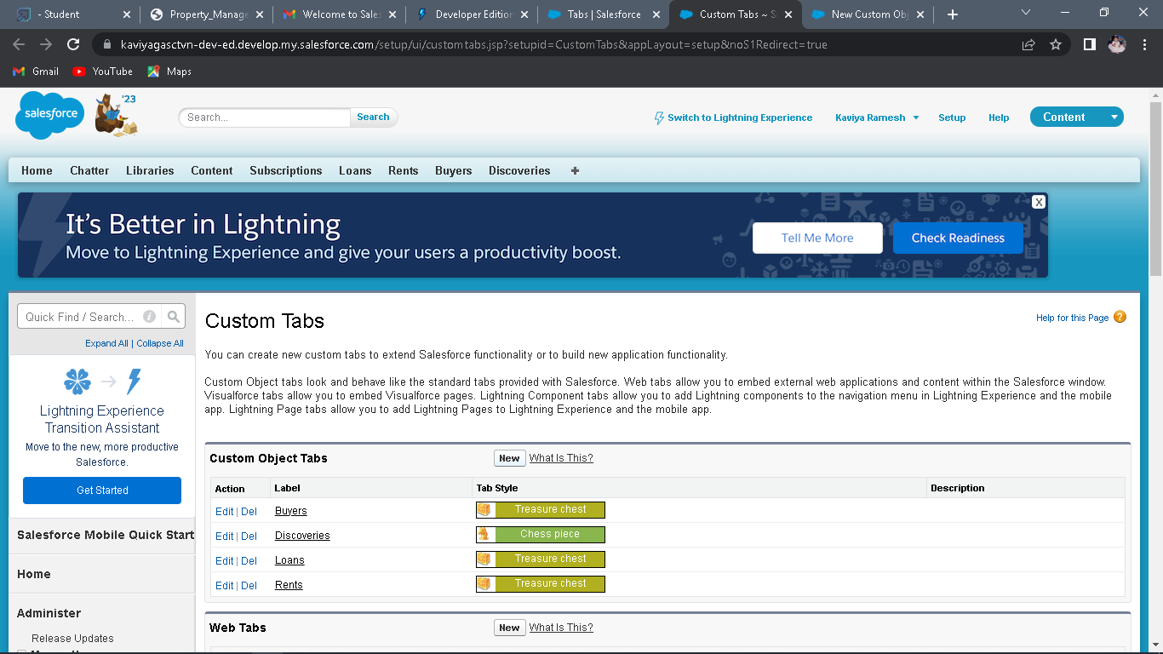

**Milestone 4:**

The Lightning App:

An app is a collection of items that work together to serve a particular function. In Lightning Experience, Lightning apps give your users access to sets of objects, tabs, and other items all in one convenient bundle in the navigation bar. Lightning apps let you brand your apps with a custom color and logo.

**Activity1:**

**Create the Lightning App**

1. Go to setup page → search “app manager” in quick find → select “app manager” → click on New lightning App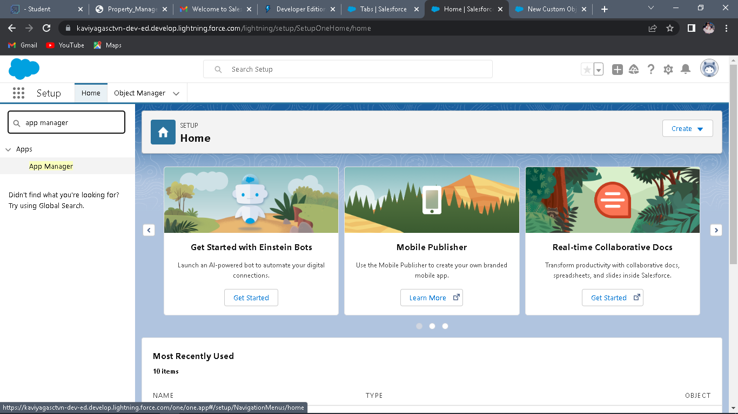

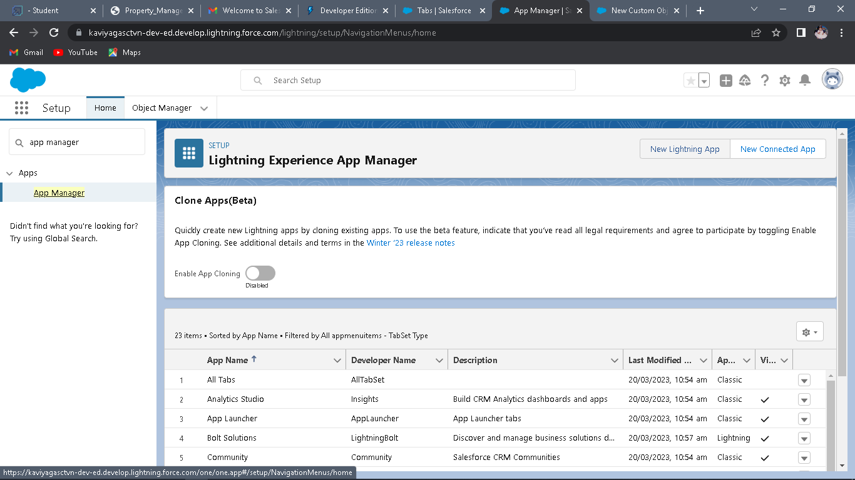

2. Fill the app name as an Property Management in app details and branding →Next → (App option page) keep it as default → Next

3. (Utility Items) keep it as default → Next → (Add Navigation Items)(add tabs Lead, Buy, Rent, Loan) → Next → (Add User Profile) Add System Administrator, Salesforce platform user, Standard User → Next.

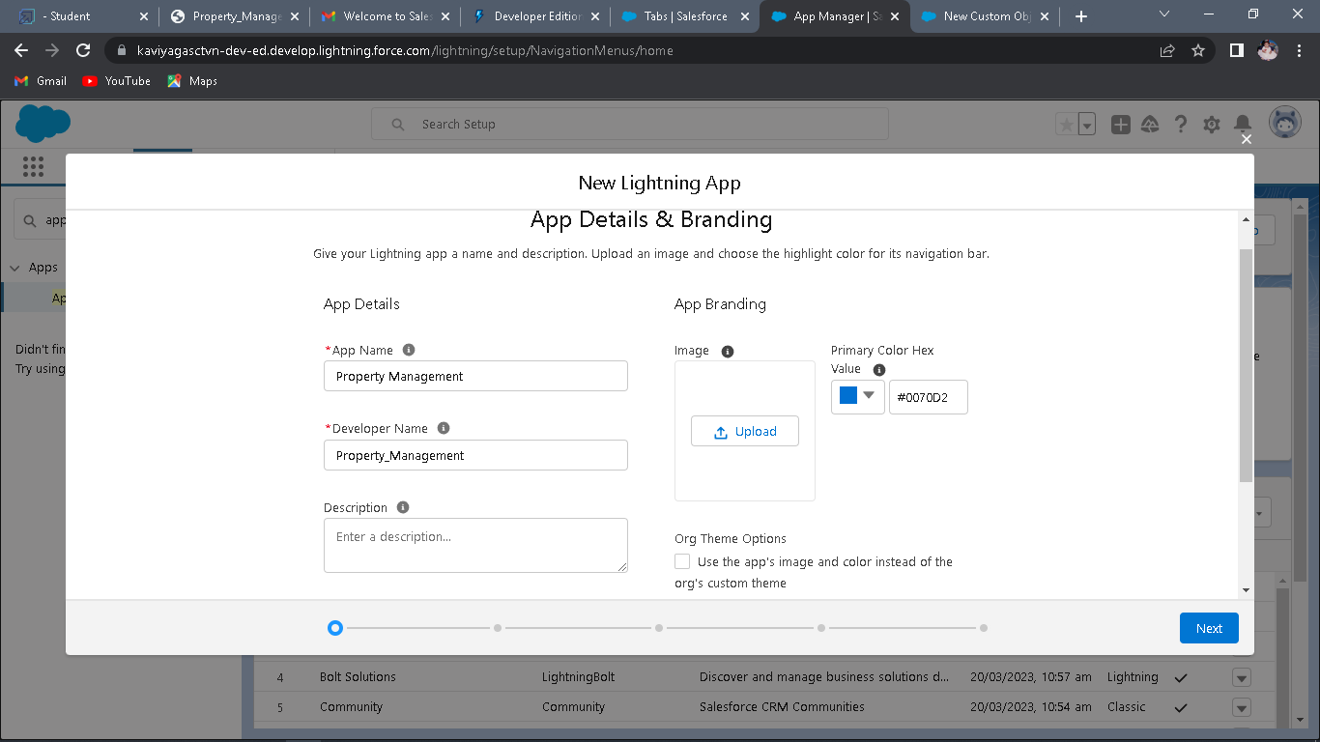

1. To Add Navigation Items: Select the items from the search bar and move it using the arrow button → Next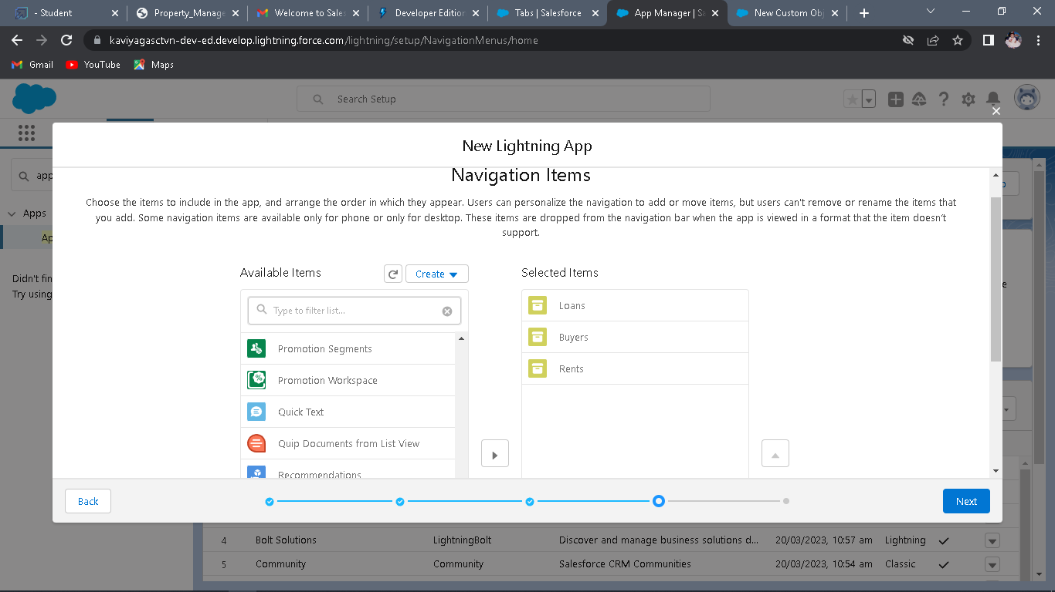
2. To Add User Profiles: Search profiles in search bar → click on the arrow button → save & finish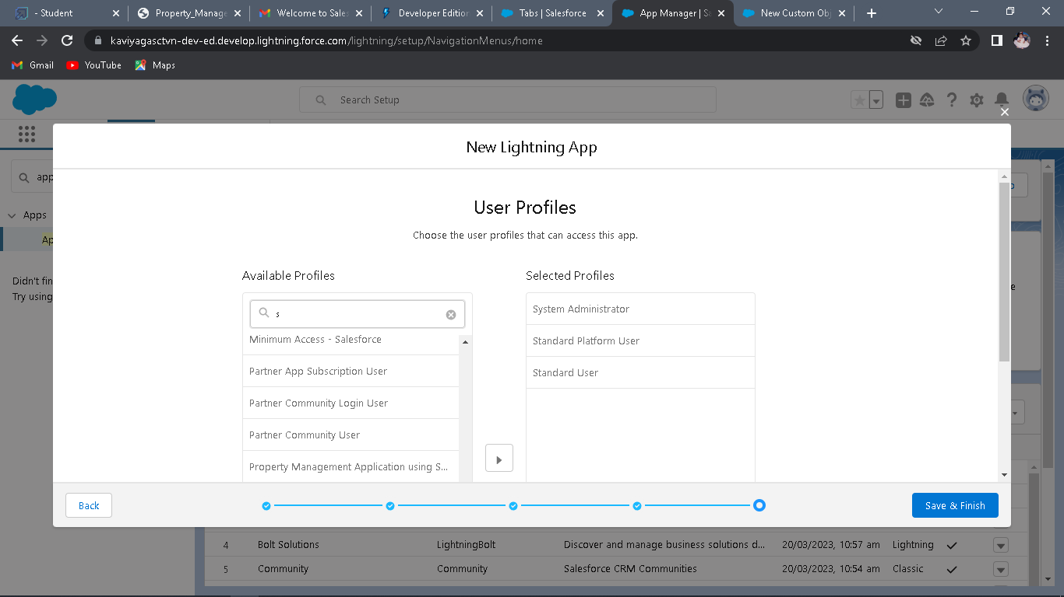

**Milestone 5:**

Fields

Fields represent the data stored in the columns of a relational database. It can also hold any valuable information that you require for a specific object. Hence, the overall searching, deletion, and editing of the records become simpler and quicker.

**Types of Fields**

● Standard Fields

● Custom Fields

**Standard Fields:**

● Created By ● Owner ● Last Modified ● Field Made During object Creation

**Custom Fields:**

On the other side of the coin, Custom Fields are highly flexible, and users can change them according to requirements.

**Activity 1:**

**Create the Lead Field**

1. Go to setup → click on Object Manager → type object name in search bar → click on the object
2. Now click on “Fields & Relationships ” → New.

3. Fill the field label name Lead → Next → Next → Save.

**Create the remaining Fields:**

Follow the Above Steps to create the Field just change the Labels for Below Fields

**Lead:**(AutoNumber Created Field while creating Object) →L-{0000}

**State:** Create the Picklist Field (Maharashtra, Gujarat, Rajasthan)(Field Dependency)

**City:**Create the Picklist(Mumbai, Pune, Nashik)(Field Dependency)

**Email:** Create the Email Select the Data Type As Email (Email)

**Phone:**Select the Field Data type as (Phone)

In the Fields and Relationship go to the Field Dependencies

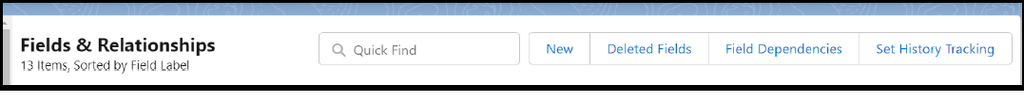

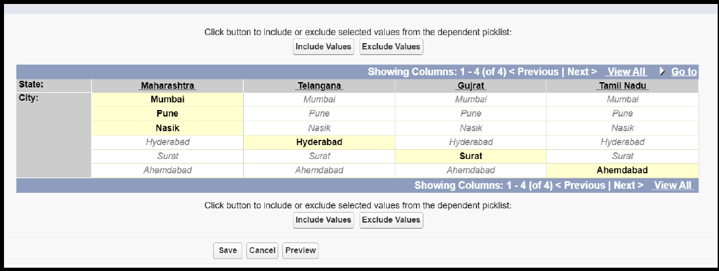

**Activity2:**

**For Object Buy**

**1. Create Field for Buy**

2. **Create Property Type:** (Picklist) (Residential, Commercial, Industrial)

3. **Discount**:(Percentage As the Field Data Type)

4. **State:**Create the Picklist Field (Maharashtra, Gujarat, Rajasthan)(Field Dependency)

5. **City**:(Take Any City for Field Dependency)

**6. Annual Amount To Be Paid**

**Activity3:**

**Create Field for Rent**

1. **Rent:**(Auto Number while Creating the object)→ R-{0000}

2. **Rental City:**Select the Text as the Field Data Name(Any City)

3. **BHK type:**(Picklist) (1BHK, 2BHK,3BHK)

**Activity4:**

**Create Field for Loan**

1. **Loan Id**: Auto generated Field Take it as Autonumber LN-{0000}

2. **Interest Rate**: (Select the Field Data Type As Currency)

3. **Term**:(Select the Field Data type as Number)

4. **Annual Loan** Field create the Number as the field data type

5. **Total Loan Instalments:**( Field create the Number as the field data type)

6. **Loan Repayment**( Field create the Number as the field data type)

7. **Loan Amoun**( Select the Field data type as Formula)

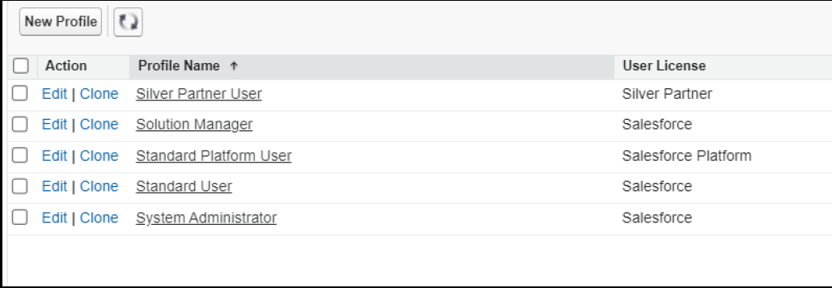

8. **For the Loan Object**→ **Go to the fields and Relationship and select the formula in**

**field data type. In Formula option select Advanced Formula and write the following**

**formula**

(**Loan_Repayment__c * (((1+( Interest_rate__c /52))^ Term__c) -1))/((**

**Interest_rate__c /52)*((1+( Interest_rate__c /52))^ Term__c))**

##Check the syntax below whether the formula syntax is correct or not

**Milestone 6:**

**Profile**

● A profile is a group/collection of settings and permissions that define what a user can do

in salesforce.

● profile controls “Object permissions, Field permissions, User permissions, Tab settings,

App settings, Apex class access, Visualforce page access, Page layouts, Record Types,

Login hours & Login IP ranges.

● You can define profiles by the user's job function. For example System Administrator,

Developer, Sales Representative.

**Types of profiles in salesforce**

**1. Standard profiles:**

● By default salesforce provide below standard profiles.

● We cannot deleted standard ones

● Each of these standard one includes a default set of permissions for all of the standard

objects available on the platform.

**2. Custom Profiles:**

● Custom ones defined by us.

● They can be deleted if there are no users assigned with that particular one.

**Activity 1:**

**To create a new profile:**

1. Go to setup → type profiles in quick find box → click on profiles → clone the desired

profile (standard user is preferable) → enter profile name → save

2. .Enter a Profile Name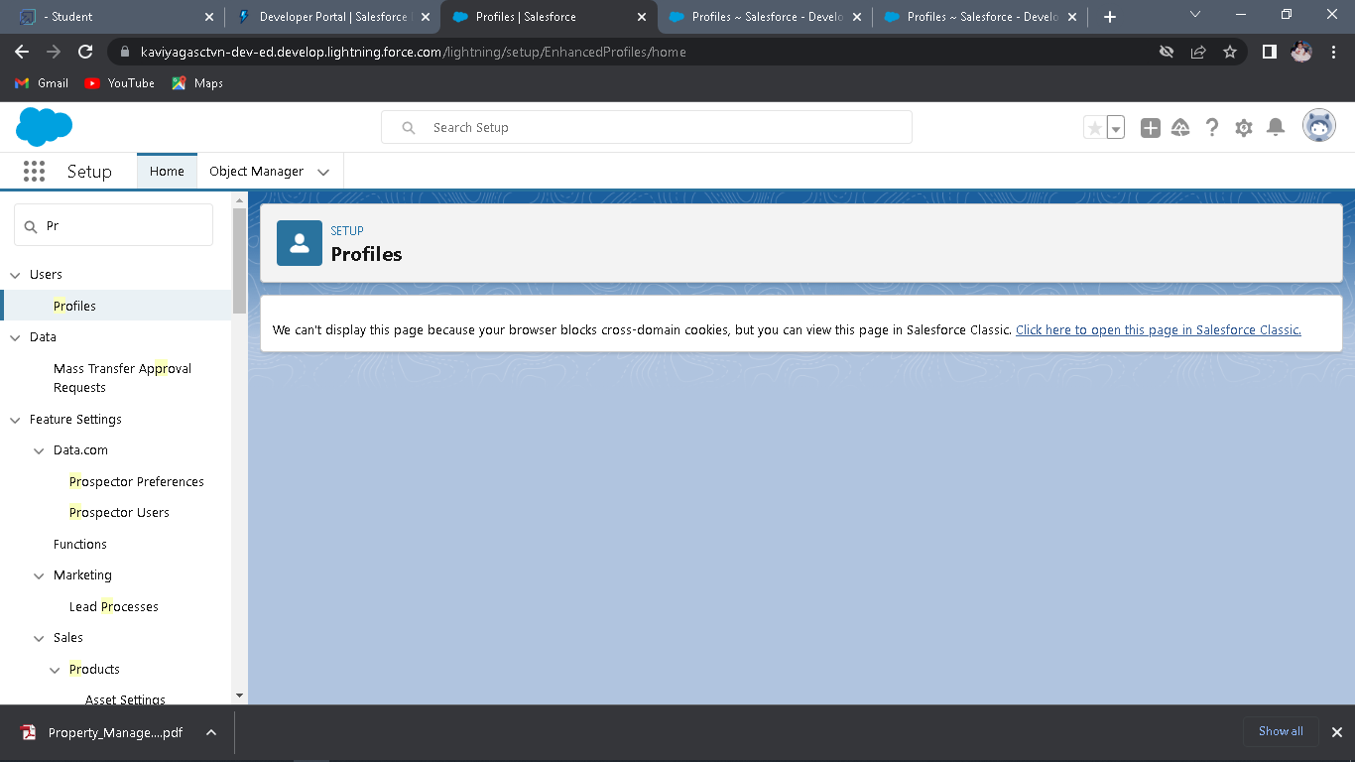3. Click on the new created profile 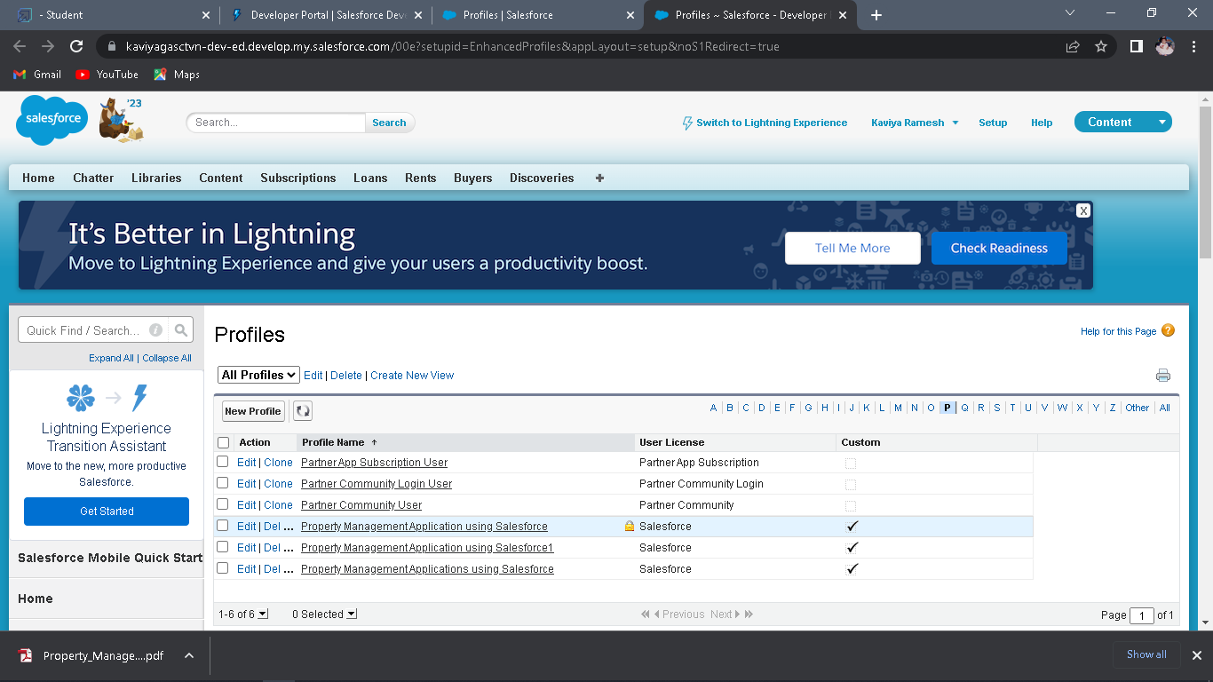

4. While still on the profile page, then click Edit.

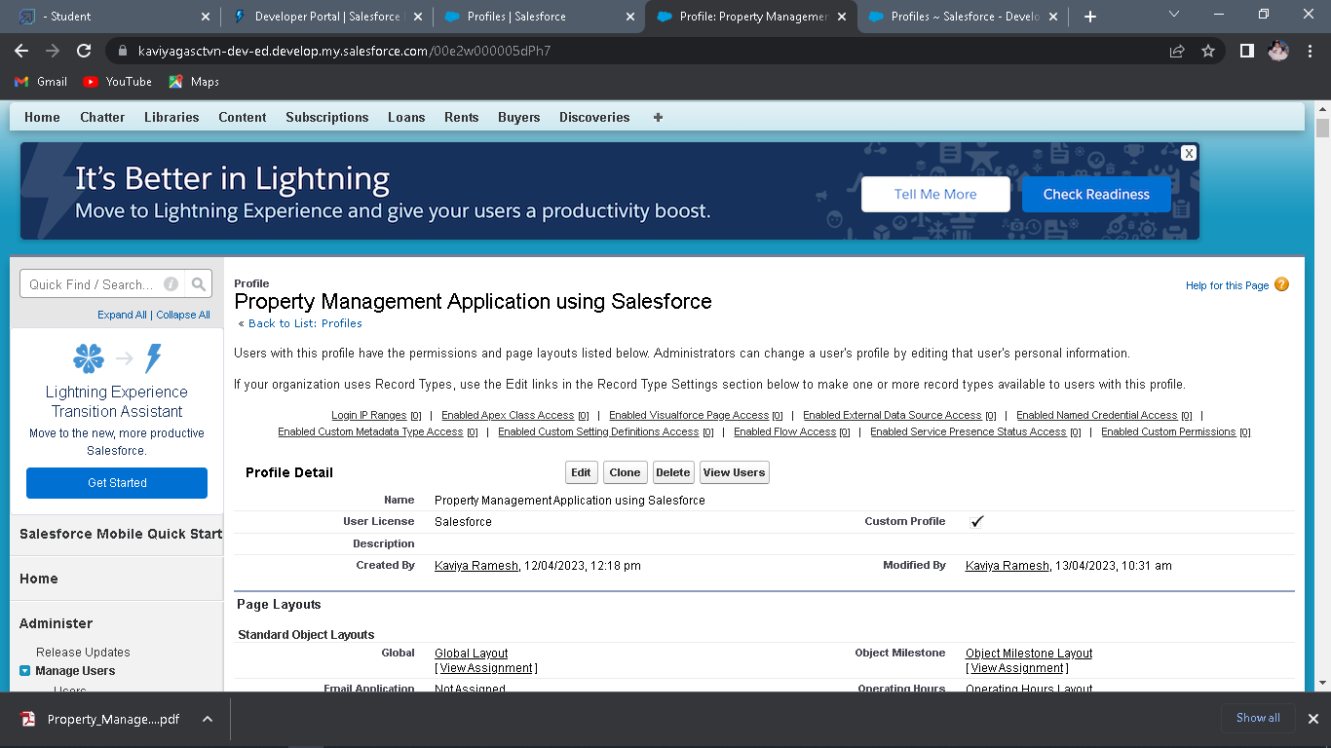

5. Scroll down to Custom Object Permissions and Give view all access permissions and assign

to the parent profile

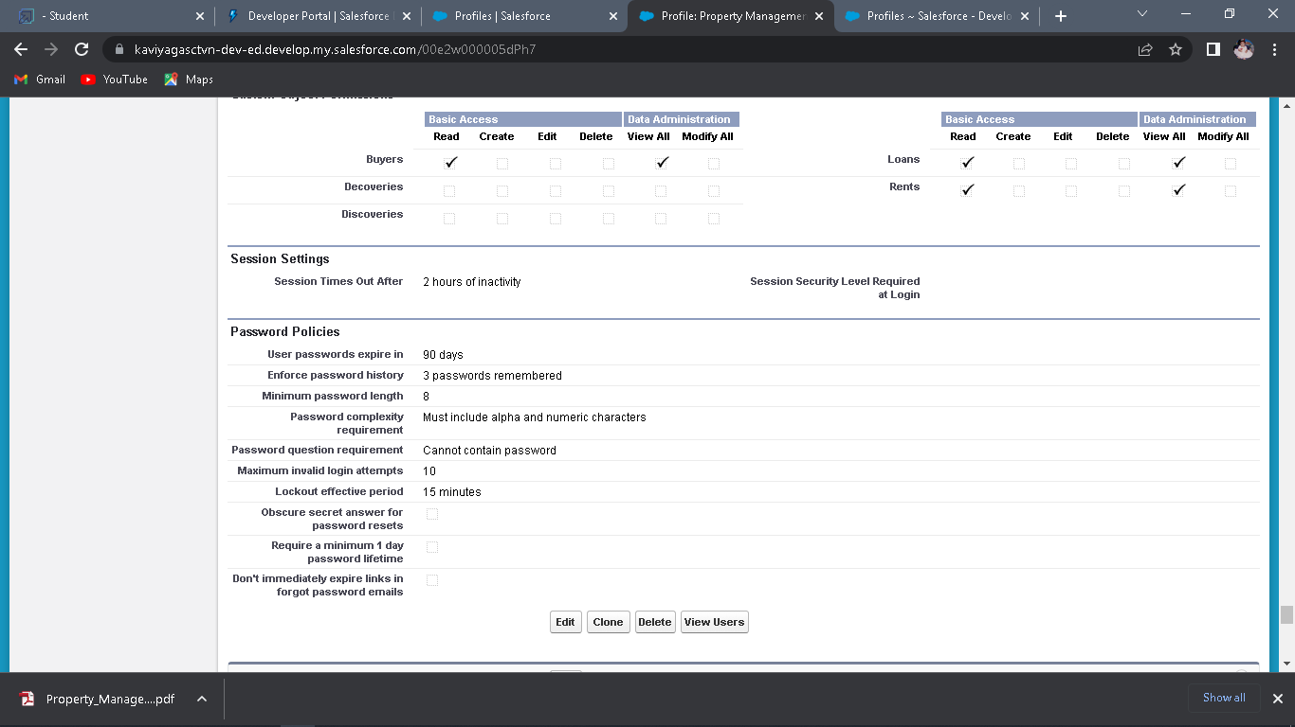

6. Sales Manager →Standard user Profile , Marketing Executive1 and Executive2→Standard

Platform User,Marketing Manager→Standard Platform User For

**Activity 2**

**Create Marketing**

1. Then In The Profile Level Give Read and Create Access to Marketing Executive and

Read, Create, Edit, Delete for the Marketing manager

2. Marketing Manager Should Have Access to Marketing Executive

**Activity 3**

**Sales:**

1. In the Profile Level Sales Manager is Having Create, Edit, Delete

2. For Sales Rep1→ Read, Create, Edit

3. For Sales Rep2→Read, Create, Edit

4. For Sales Rep3→ Read only.

**Milestone7-New User**

● A user is anyone who logs in to Salesforce. Users are employees at your company, such

as sales reps, managers, and IT specialists, who need access to the company's records.

● Every user in Salesforce has a user account. The user account identifies the user, and the

user account settings determine what features and records the user can access.

**Activity 1: Create User**

1.Go to setup → type users in quick find box → select users → click New user.

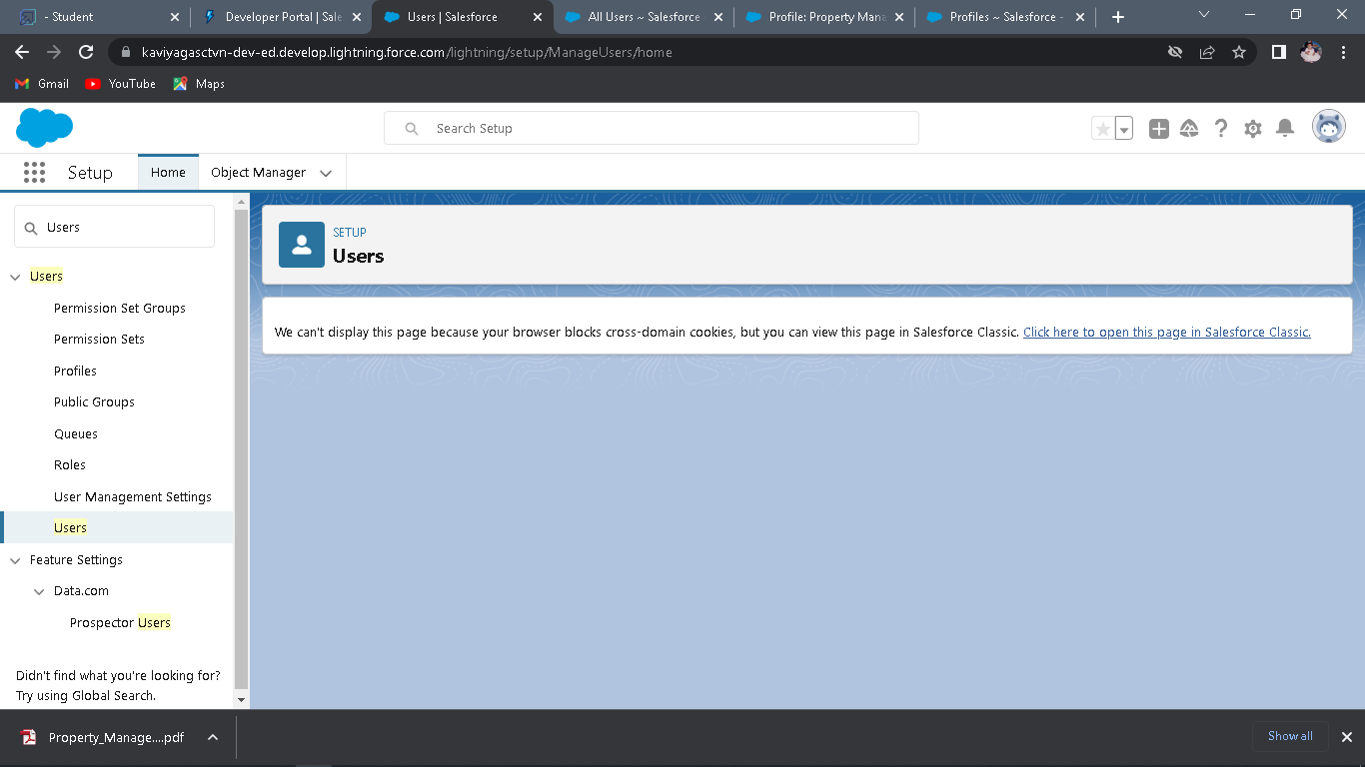

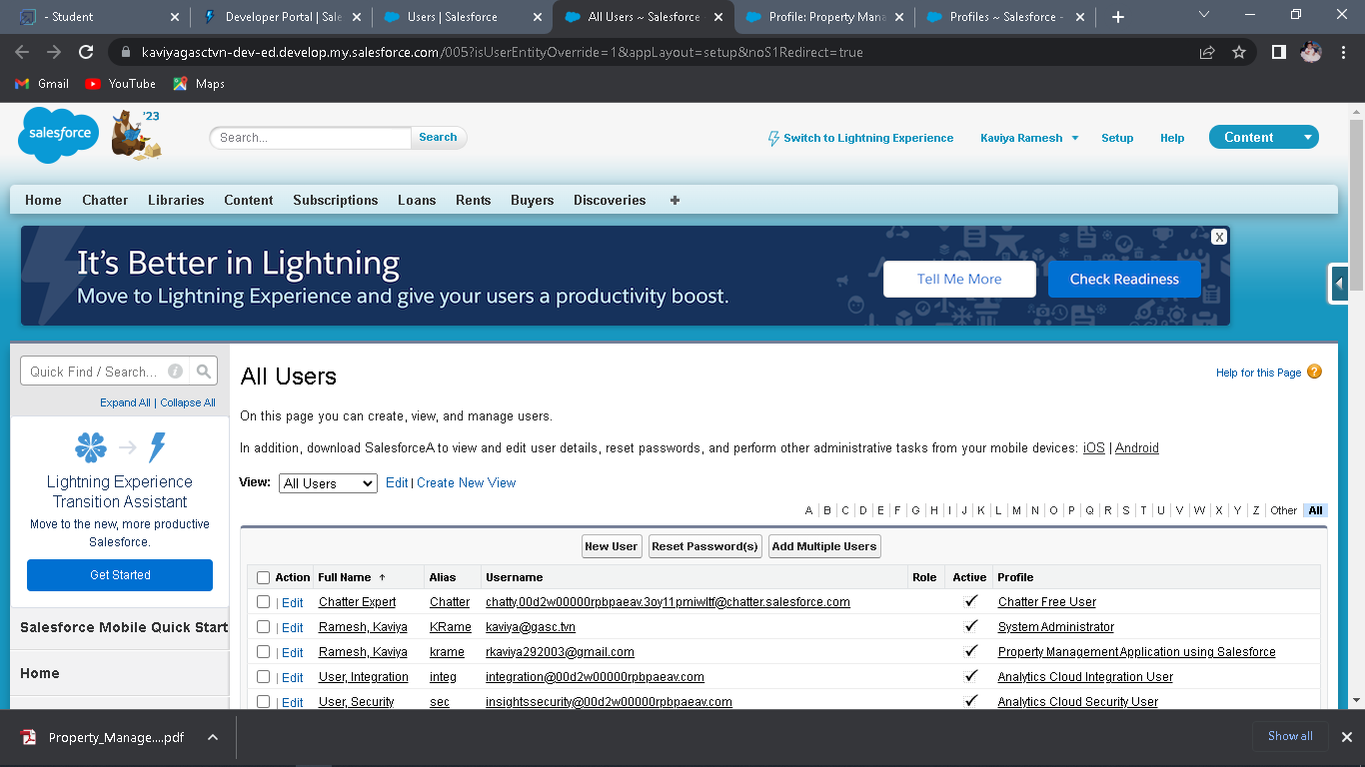

2. Fill in the fields (first name, last name, alias, email id, username, nick name, role, user

license, profiles) → save.

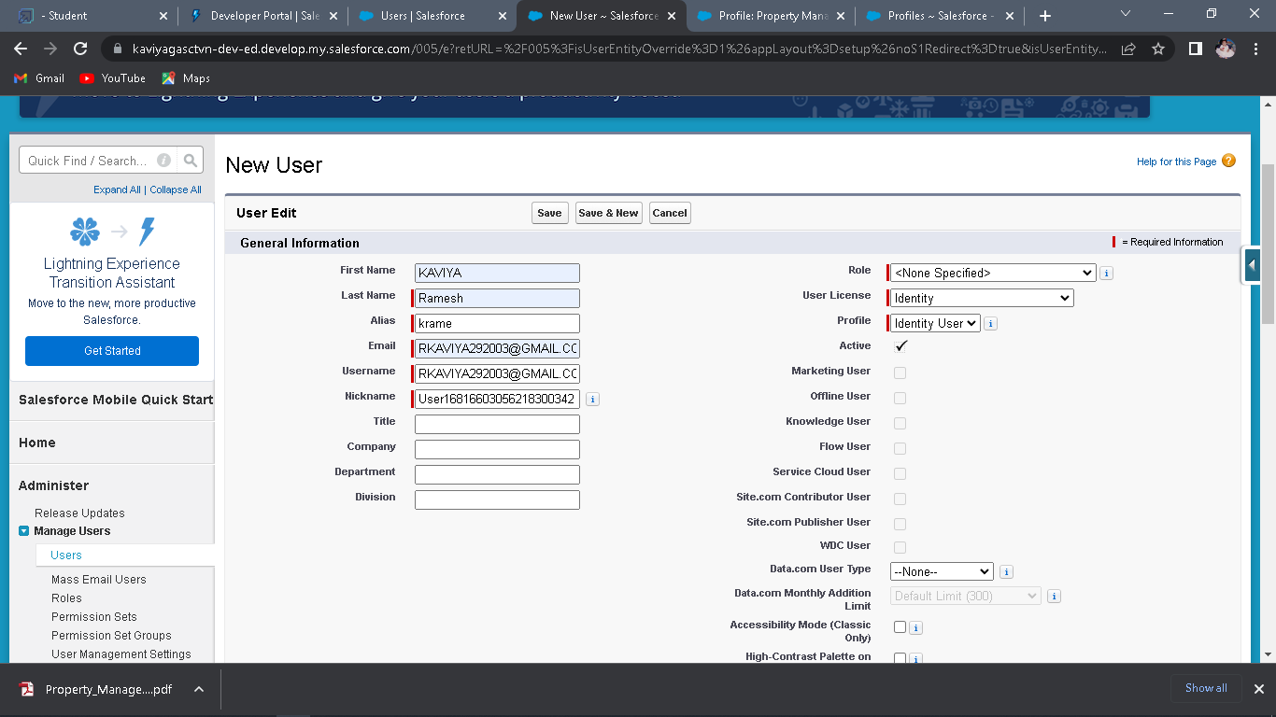

**Milestone 8:**

**Permission Set**

A permission set is a collection of settings and permissions that give users access to

various tools and functions. Permission sets extend users' functional access without changing their profiles.

Users can have only one profile but, depending on the Salesforce edition, they can have multiple permission sets.

**Activity 1:**

**Create the Permission Sets**

1. Go to setup → type “permission sets” in quick search → select permission sets → New.

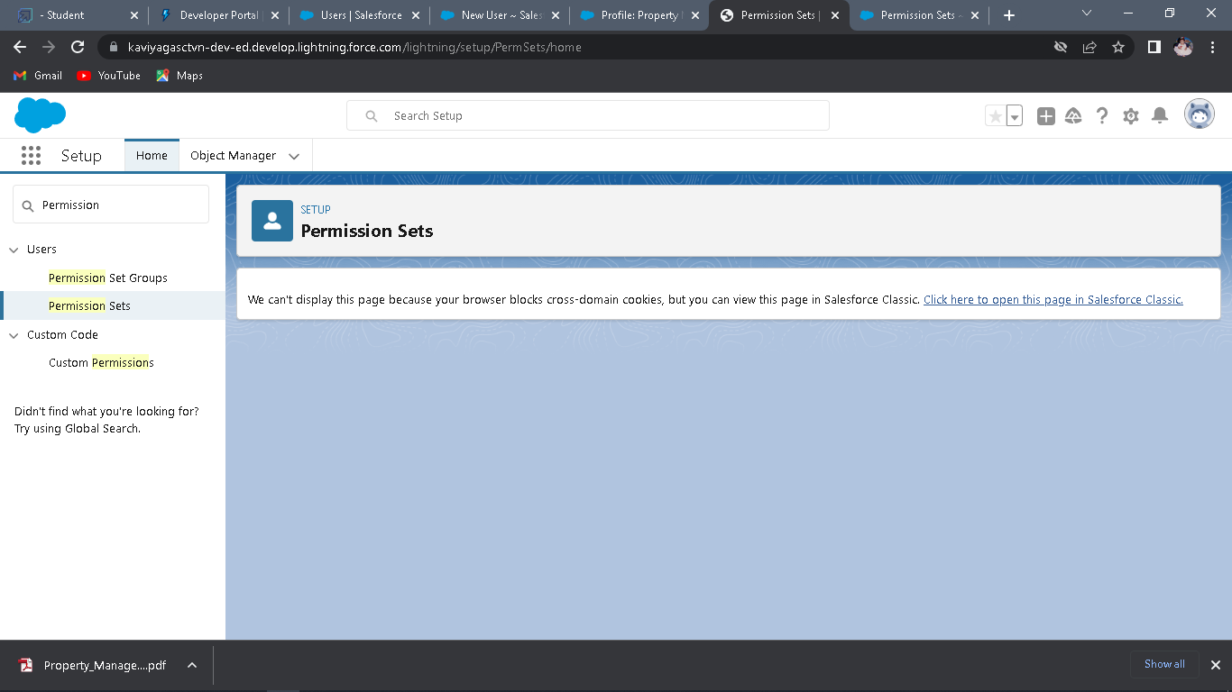

1. Enter the label name → save.

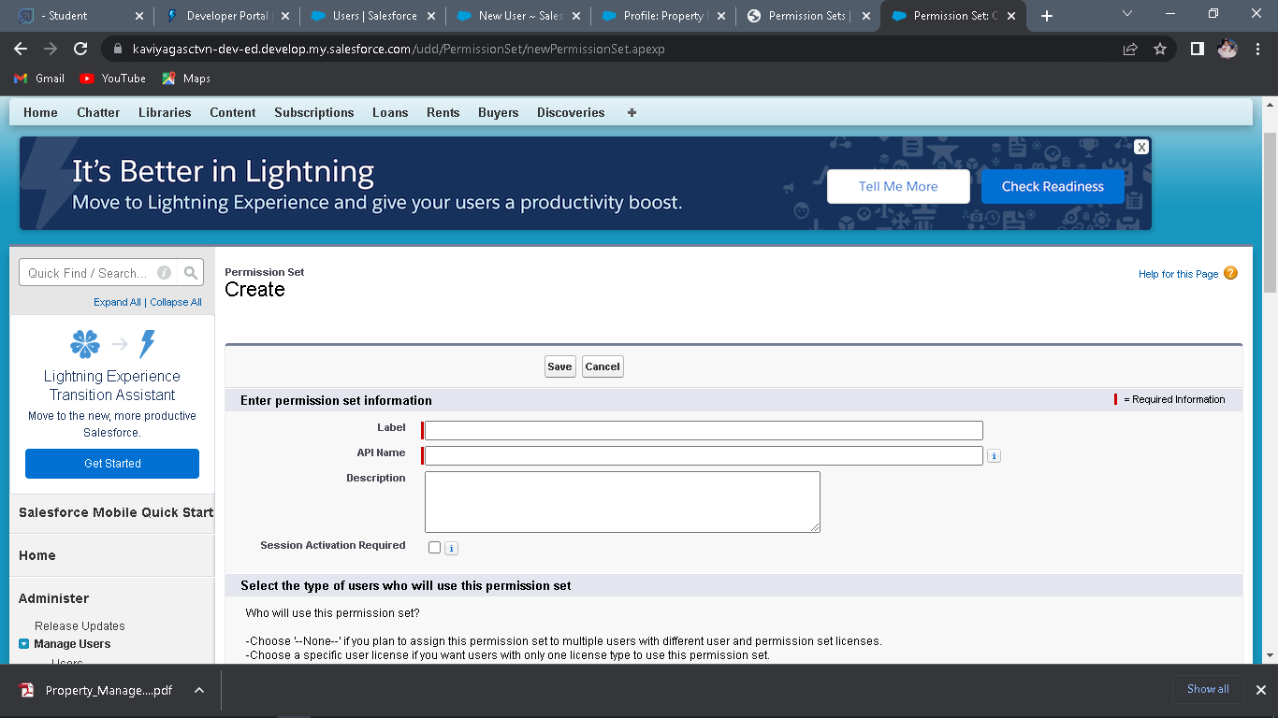

3. After saving the permission click on the Manage assignment

4. Now click on the Add Assignment

5. Now select the users and click on save

6. Go to permission set and add the access For Sales Rep3 give Access with Create

permission for the User

**Milestone 9:**

**Setup For OWD**

Organization-Wide Defaults, or OWDs, are the pattern security rules that you can follow for your Salesforce instance. Organization Wide Defaults are utilized to confine who can access what information in your CRM.

Primarily, there are four levels of access that can be set in Salesforce OWD and they are-

● Public Read/Write/Transfer (only available of Leads and Cases)

● Public Read/Write

● Public Read/Only

● Private

**Activity1:**

**Create OWD Setting**

1. Setup, use the Quick Find box to find Sharing Settings.

2. Click Edit in the Organization-Wide Defaults area.

3. For each object, select the default access you want to give everyone.

4. To disable automatic access using your hierarchies, deselect Grant Access Using

Hierarchies for **Lead, Rent** custom object

5. Click Edit and from the Drop Down select private for internal and external

6. This Setting is for all the User Which have been Created

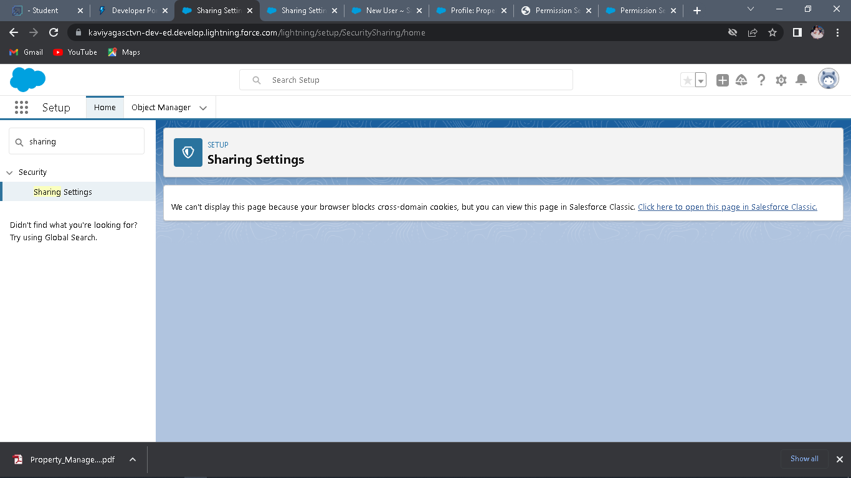

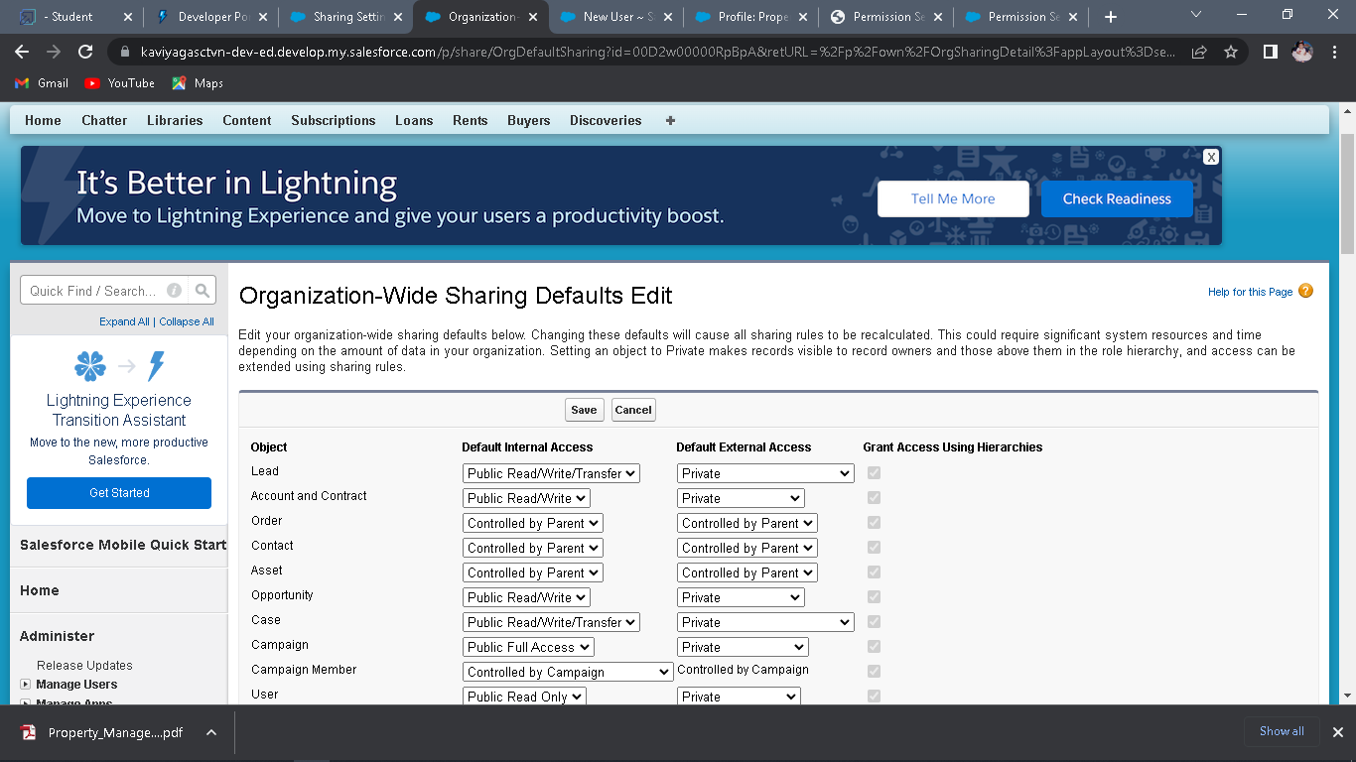

**Activity 2:**

**Marketing**

1. Create the Record Level OWD Setting give it As A Private To Marketing manager And

Marketing Executive

**Sales:**

1. Sale Manager OWD is Set As Private similarly sales Rep1, Sales Rep2 same OWD for

them

**Milestone 10**

**Report**

**Types of Reports in Salesforce**

Tabular

Summary

Matrix

Joined Reports

**Activity 1:**

**Create Report-**

1. Go to the app → click on the reports tab

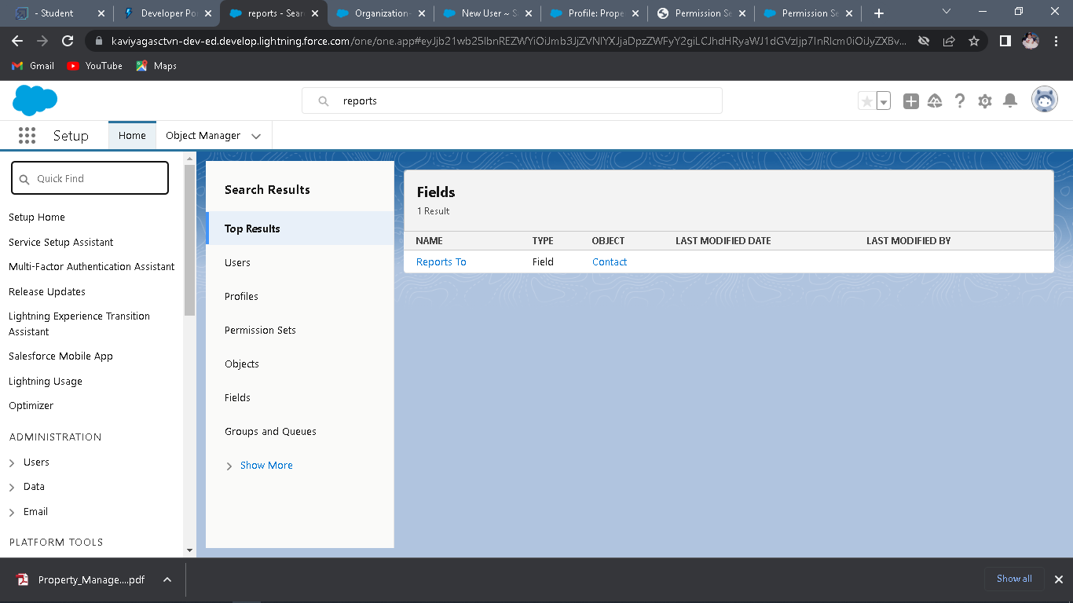

2. Click New Report

3. Select report type from category or from report type panel or from search panel → click

on start report

4. Customize your report, then save or run it.

**Create Report for following Condition**

1. Create the Report of the Total Number of Loan Passed for for getting the Amount For the

Property

2. The Condition should be Like Loan Amount **>=** to 5000$

**Milestone11-Dashboards**

Dashboards help you visually understand changing business conditions so you can make

decisions based on the real-time data you’ve gathered with reports. Use dashboards to help users identify trends, sort out quantities, and measure the impact of their activities. Before building, reading, and sharing dashboards, review these dashboard basics.

**Activity1:**

**Create dashboards**

1. Go to the App Launcher and select the Dashboards

2. Select add component

3. Select the folder select the following option new lead with loan Amount

4. Select in which format you want display chart

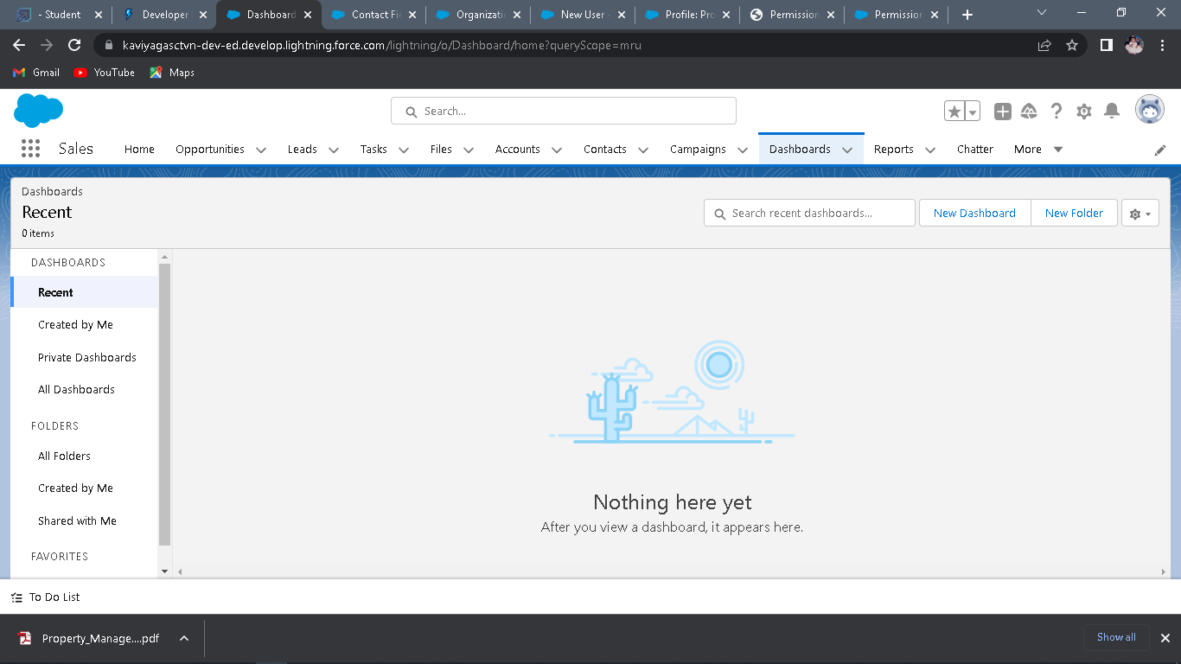

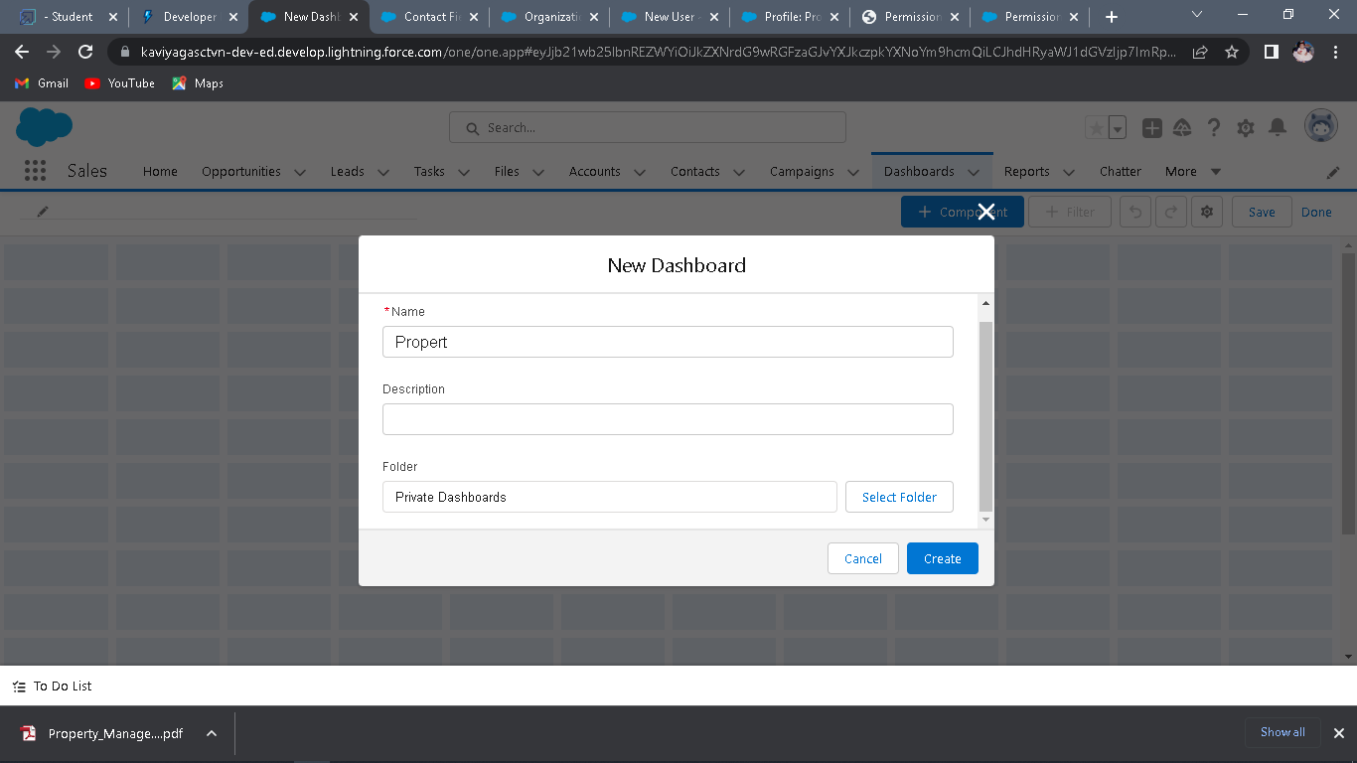

**Activity2:**

**Create Dashboard**

1. Create the Dashboard for the Same Take Any Type of Dashboard( Chart) And Display It

on The App Home Page.

# Trailhead Profile Public URL

**Team Lead-** <http://trailblazer.me/id/kramesh72>

**Team member 1-**<https://trailblazer.me/id/kirthi17>

**Team member 2-**<https://trailblazer.me/id/mmurugan42>

**Team member 3-**<https://trailblazer.me/id/kveni251>

**Team member 4-**<https://trailblazer.me/id/ezhil321>

# 5. ADVANTAGES

* Enterprise-level platform security that improves with each release
* Infinite customizability of the system
* Over 4,000 native integrations both free and paid
* Consolidated databases via integration of various data sources to build a central database of accounts, properties, tenants, or listings.
* Data integration of various data sources

# DISADVANTAGES

* Customer experience may worsen due to staff over reliance on the system.
* Security and data protection issues with centralized data.
* The excess initial time and productivity cost implementation.
* Requires a process-driven sales organization.
* CRM may not suit all business.

# 6.APPLICATIONS

Salesforce is used for streamlining sales, service, and marketing activities via industry apecific products and seamless software integration.

It offers solutions for various needs such as Sales cloud, Service cloud, Marketing Cloud, Community Cloud, Field Services, CPQ and Billing.

# 7.CONCLUSION

Student Internals Mark Management System deals with student details, academic related

Reports, college details and course details. It track all the details of a student from the day one to the end of his course which can be used for all reporting purpose, tracking of progress in the course, completed semester, upcoming semester details, exam details, project or an other assign

# 8.FUTURE SCOPE

Scope of education means range of view, outlook, fields or opportunity of activity, operation and application of education. Education has wider and application .